* **For Data Analysis using DAX Functions:**

1.Create a new table that consolidates information from multiple tables using DAX

Answer- for this I have created a new table name HealthExpenditureSummary then apply summarise formula.

SUMMARIZE('Health Expenditure',Country [CountryID],'Years'[YearID],

    "CountryName", MAX(Country[CountryName]),

    "Year", MAX('Years'[Year]),

    "TotalExpenditure", SUM('Health Expenditure'[ExpenditureAmount]),

    "TotalGDP", SUM(GDP[GDPAmount]),

    "TotalPopulation", SUM(Population[PopulationCount])

2. Find the countries/regions with the highest and lowest health expenditure for all years.

3.Determine the percentage of health expenditure as a share of GDP for each country

Answer for this I have created a new table health expenditure summary 2

health expenditure summary 2 = SUMMARIZE('Health Expenditure',Country[CountryID],'Years'[YearID],"country name",MAX(Country[CountryName]),"year",max(Years[Year]),"total expenditure",SUM('Health Expenditure'[ExpenditureAmount]),"total GDP",SUM(GDP[GDPAmount]),"total population",SUM(Population[PopulationCount]))

4. Calculate the average health expenditure per capita for each country/region.

Answer – For this I have created a new table name AVG_HealthExp_per_capita

Average_Health_Exp_Per_Capita = DIVIDE(HealthExpenditureSummary[TotalExpenditure],HealthExpenditureSummary[TotalPopulation])

For Visualisation

1.Calculate the year-to-year percentage change in health expenditure.

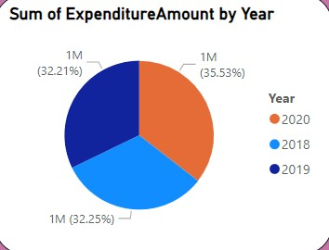

Hear I use pie chart because it will be best for providing information and I put sum of total health expenditure in values and years in legend as it in year

2.Calculate the average annual growth rate of health expenditure over a selected period

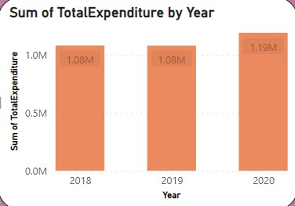

Here I used clusted column chart as it given annually wise health expenditure. And for cluster column chart I put year in X axis and total expenditure in Y axis

3.Create a line chart to visualise the trend of health expenditure over the years for selected countries/regions.

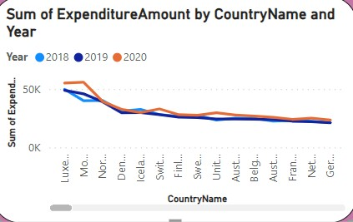

For line chart in visual pannel I put country name in X axis and sum of expenditure in Y axis and year in legend.

4.Create a bar chart to compare health expenditure across different countries/region for a 2020 year.

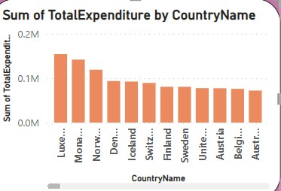

In visual panel for bar chart I put country name in X axis and sum of total expenditure in Y axis

5.Use a scatter plot to explore the relationship between health expenditure and GDP.

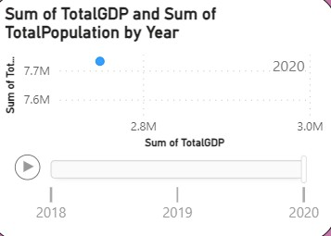

Here I put TotalGDP in X axis and total population in Y axis and put year in play axis

6.Utilise a map visualisation to show health expenditure distribution geographically.

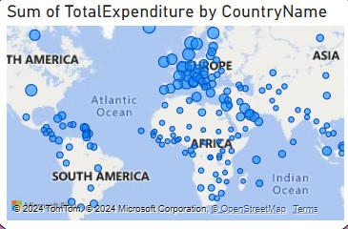

Here I put country name in location in visualization panel and total expenditure in bubble section. Here bubble size represent maximum of health expenditure of country